

ASSOSA UNIVERSITY

COLLEGE OF COMPUTING AND INFORMATICS

DEPARTMENT OF COMPUTER SCIENCE

WIRELESS COMMUNICATION AND MOBILE COMPUTING

GROUP ASSIGNMENT

TITLE: WIRELESS NETWORK BASICS AND WIRELESS TRANSMISSION MEDIA

PREPARED BY:

1.Birhanu Dagnaw RU/1699/10

2.Awel Kassim RU/1517/100

3.Mestenanat Zenebe RU/1872/10

4.Tegen Andualem RU/0382/10

5.Tiruneh Simachew RU/0159/10

6.Kegnash Mekonen RU/ 1704/10



Contents

Wireless Network Basics 1

Introduction 1

WIRELESS TRANSIMISSION 1

SIGNALS 2

Types of Wireless Signals 2

Wi-Fi Signals 2

Frequency Allocation 2

Example Frequency Ranges 3

Modulation 3

Receivers and Transmitters 7

Frequency Regulation 7

Frequency Regulation and Examples 8

Benefits of Frequency Regulation 8

Wireless Transmission Media 8

Infrared 9

Characteristics of Infrared: 9

Broadcast Radio 10

Cellular Radio 10

Microwaves 12

Satellite Communications 13

Sources 14

# Wireless Network Basics

## Introduction

* Wireless networks are computer networks that are not connected by cables of any kind. The most common wired networks use cables connected to Ethernet ports on network router on one end and to a computer or other device on the cable's opposite end. The use of a wireless network enables enterprises to avoid the costly process of introducing cables into buildings or as a connection between different equipment locations.
* The bases of wireless systems are radio waves, an implementation that takes place at the physical level of network structure.

There are four main types of wireless networks:

* Wireless Local Area Network (LAN): Links two or more devices using a wireless distribution method, providing a connection through access points to the wider Internet.
* Wireless Metropolitan Area Networks (MAN): Connects several wireless LANs.
* Wireless Wide Area Network (WAN): Covers large areas such as neighboring towns and cities.
* Wireless Personal Area Network (PAN): Interconnects devices in a short span, generally within a person’s reach.

## WIRELESS TRANSIMISSION

Wireless transmission is a form of unguided media. Wireless communication involves no physical link established between two or more devices, communicating wirelessly. Wireless signals are spread over in the air and are received and interpreted by appropriate antennas.

When an antenna is attached to electrical circuit of a computer or wireless device, it converts the digital data into wireless signals and spread all over within its frequency range. The receptor on the other end receives these signals and converts them back to digital data.

A little part of electromagnetic spectrum can be used for wireless transmission.

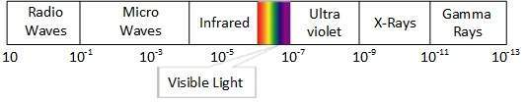

## SIGNALS

Wireless signals are important because they can transfer information -- audio, video, our voices, data -- without the use of wires, and that makes them very useful.

Wireless signals are **electromagnetic waves** travelling through the air. These are formed when electric energy travels through a piece of metal -- for example a wire or antenna -- and waves are formed around that piece of metal. These waves can travel some distance depending on the strength of that energy.

For more on how electromagnetic signals work, check the #External Resources section at the end of this document.

### Types of Wireless Signals

There are many, many types of wireless technologies. You may be familiar with AM and FM radio, Television, Cellular phones, Wi-Fi, Satellite signals such as GPS and television, two-way radio, and Bluetooth. These are some of the most common signals, but what makes them different?

|  |  |  |  |  |
| --- | --- | --- | --- | --- |
| Radio | TV | Phone | Satellite | Laptop |

### Wi-Fi Signals

When building a network, you will be using Wi-Fi technology, which has some unique characteristics you will need to know.

There are two types of Wi-Fi signal, based on the frequencies they use:

1. **2.4GHz** - A lower frequency, this is the more common Wi-Fi technology in use today. Many devices use it, so the signals can become more crowded and interfere with each other. It can pass through walls and windows fairly well.
2. **5GHz** - This higher frequency technology is used by fewer devices, and can sometimes achieve higher speeds because the frequencies are less crowded. It cannot pass through walls and windows as well as the 2.4GHz band signals, so the range of 5GHz technology is often shorter.

## Frequency Allocation

(Or **spectrum allocation** or [spectrum management](https://en.wikipedia.org/wiki/Spectrum_management)) is the allocation and regulation of the [electromagnetic spectrum](https://en.wikipedia.org/wiki/Electromagnetic_spectrum) into radio [frequency bands](https://en.wikipedia.org/wiki/Frequency_bands), which is normally done by governments in most countries. Because [radio propagation](https://en.wikipedia.org/wiki/Radio_propagation) does not stop at national boundaries, governments have sought to harmonize the allocation of RF bands and their standardization signals occupy a spectrum, or wide range, of frequencies: the rate at which a signal vibrates. If the signal vibrates very slowly, it has a low frequency. If the signal vibrates very quickly, it has a high frequency.

Frequency is measured in Hertz, which is the count of how quickly a signal changes every second. As an example, FM radio signals vibrate around 100 million times every second! Since communications signals are often very high in frequency, we abbreviate the measurements for the frequencies - millions of vibrations a second is Megahertz (MHz), and billions of vibrations a second is Gigahertz (GHz). One thousand Megahertz is one Gigahertz.

|  |
| --- |
| Example Frequency Ranges Below we can see the span of frequencies that are commonly used in communications. Broadcast transmitters for AM, FM and Television use frequencies below 1000 MHz, Wi-Fi uses two bands at higher frequencies - 2.4 and 5GHz. Cellular phones use many different freqsuencies.  Wireless spectrum   1. The frequencies from left to right: 2. AM Radio: Around 10MHz 3. FM Radio: Around 100MHz 4. Television: Many frequencies from 470MHz to 800MHz, and others. 5. Cellular phones: 850MHz, 1900MHz, and others 6. Wi-Fi: 2.4GHz 7. Satellite: 3.5GHz 8. Wi-Fi: 5GHz |

Modulation

In addition to having different frequencies, wireless signals can be different in the way they convey information. A wireless signal needs to be modulated--or changed--to send information. There are many types of modulation, and different technologies can use one or more types to send and receive information. In the two examples below -- AM and FM radio -- the M stands for modulation. The type of modulation is what makes them different.

**Example one: AM radio.** The A in AM comes from Amplitude - the energy or strength of the signal, operating at a single frequency. An un-modulated AM wave might look like:  
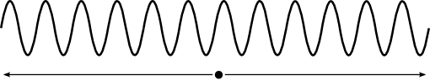

And a modulated AM radio wave has higher and lower energy (amplitude) waves indicating higher and lower audio frequencies in the signal:  
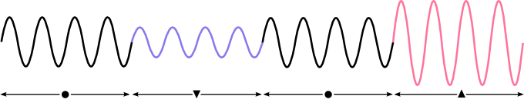

From left to right, we have the normal, un-modulated wave, then the lower amplitude wave (representing low points in audio waves), then the higher amplitude wave (representing crests or high points in audio waves).

A more detailed version of an AM signal is below:  
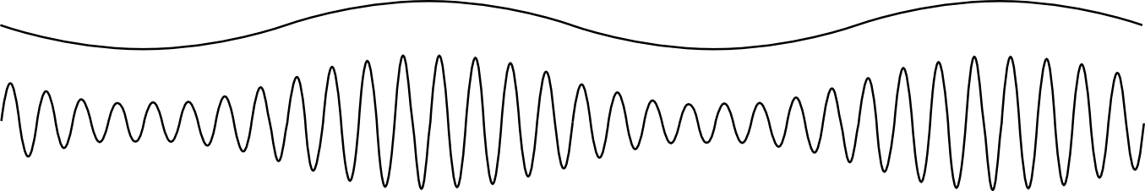

The audio signal is the wave on the top, with the corresponding Amplitude Modulated wave below it.

**Example two: FM radio.** The F in FM comes from Frequency - defined by how quickly the wave vibrates every second. An un-modulated FM wave might look like:  


And a modulated FM radio wave has higher and lower frequencies indicating higher and lower audio frequencies in the signal:  
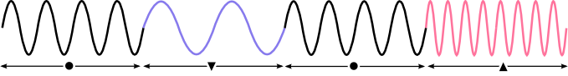

From left to right, we have the normal, un-modulated wave, then the lower frequency wave (representing lower audio amplitudes), then the higher frequency wave (representing higher audio amplitudes).

The type of modulation various technologies use to communicate can be very different, and are often not compatible. Satellite equipment cannot speak directly to your laptop or smartphone, which uses Wi-Fi to send and receive information. This is because the radios in different devices can listen only to certain types of modulations and frequencies.

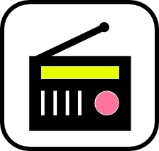As an example, some broadcast radio receivers have a switch to select between AM and FM signals, for two reasons: they use different frequencies to transmit, and they use different modulation types. If you try and listen to an AM signal with a radio in FM mode, it won’t work. The opposite is also true - in AM mode, an FM signal doesn’t make sense to the receiver. It is important that transmitters and receivers use the same frequencies and modulation types to communicate.

Devices in your daily life use many types of wireless signals. Look at the table below to see the various frequencies and types of modulation each uses:

|  |  |
| --- | --- |
| **Technology or device** | **Type of wireless signal** |
| Television | 1. Analog video - Amplitude modulated from 50MHz to 800MHz 2. Digital video - complex modulation from 200MHz to 800MHz |
| Cell phone | 1. Voice - analog or digital modulation from 800MHz to 900MHz 2. 3G, 4G or LTE - digital modulation from 1700MHz to 1900MHz and others 3. Bluetooth - digital modulation at 2400MHz 4. Walkie-talkie / two-way radio - analog AM, FM or digital modulation over many frequencies |
| Satellite | 1. Many types of signals - voice, audio, video, data 2. Many modulation types - analog and digital 3. Many, many frequencies - 3400MHz, 5900MHz, 10.7GHz, 14.5GHz, 23GHz, and many others. |
| Laptop | 1. Wi-Fi - digital modulation at 2400MHz or 5000 to 5800MHz. 2. Bluetooth - digital modulation at 2400MHz |
| Radio | 1. AM Radio - AM modulation from 0.6MHz to 1.6MHz 2. FM Radio - FM modulation from 88MHz to 108MHz |

Nearly every device or technology uses a different wireless frequency and modulation. This means most devices can only understand a very specific kind of wireless signal.

### Receivers and Transmitters

When a device sends out a wireless signal, it is called a transmitter. When another device picks up that wireless signal and understands the information, it is called a receiver. In the case of FM radio, there is one transmitter--owned and operated by the radio station--and many receivers that people listen to the station with. When a device has both a transmitter and a receiver, it is sometimes called a transceiver. Devices such as routers can both transmit and receive, which is what makes them useful for building networks--you probably want to be able to send messages to your neighbors and out to the world, as well as receive messages!

**Quick Activity:** What devices do you own or use frequently that are transmitters, receivers or transceivers? Fill in some examples below each type:

|  |  |  |
| --- | --- | --- |
| **Transmitter** | **Receiver** | **Transceiver** |
| Tower | Receiver | Cell |
| **Examples:** | **Examples:** | **Examples:** |

Do you use more transmitters, receivers, or transceivers throughout the day? What is different about the way you use each of these?

## Frequency Regulation

Frequency Regulation is the process by which the alternating currency in any electrical grid is maintained within the right tolerance bounds by synchronizing generation assets for electrical grid stability. It involves maintenance of the correct frequency throughout the system or grid to ensure there are no power surges in other areas.

It is vital for the electric power system to maintain a near real-time balance in the grid between the generation and load in the transmission process.

Frequency Regulation is a tool employed by the electric grid operators to restrain the system frequency from getting too high or too low and helps maintain it at 60 HZ.

It also means regulation of the transmitted nominal frequency or the alternating current (AC) in an [electric power system](https://en.wikipedia.org/wiki/Electric_power_system) from the generation site to the end-user. In most countries, the required frequency is 50 HZ, but in America and Australia, the level of frequency is 60 HZ.

### Frequency Regulation and Examples

Frequency regulation is typically a “power storage” application of electricity which ensures increased grid stability. To better understand the concept of Frequency Regulation, let’s look at some examples or types.

* Generator inertia – It regulates the initial frequency decline after electrical power disturbance.
* Adding and subtracting generation assets – Synchronizing the generation assets helps regulate the production of power.
* Dedicated demand response- It adjusts and monitors power consumption based on power demands.
* Electricity storage – It helps control the amount of power usage and helps maintain power supply and enhance grid stability.

Frequency regulation is a typical component of [ancillary services](https://greencoast.org/terms/ancillary-services/) that are provided to the grid.

### Benefits of Frequency Regulation

* Frequency regulation assists in the maintenance of the interconnection frequency.
* It helps to manage the differences that occur between the actual and scheduled power flows between various control areas.
* Frequency regulation also helps match and balance power generation and direct load within the control area.

# Wireless Transmission Media

* Wireless transmission media transmits the electromagnetic waves without using any physical medium.
* In Wireless transmission media, air is the media through which the electromagnetic energy can flow easily.
* A wireless transmission media uses radio waves and infrared light waves as a medium for their signals to be able to transfer data.
* Examples of wireless transmission media are infrared, broadcast Radio, cellular radio, communications satellite, and a microwave.

## Infrared

Infrared (IR) is a wireless transmission medium that sends signals using infrared light waves. An infrared transmission is a wireless technology used for communication over short ranges.

Mobile computers and devices, such as a mouse, printer, and smart phone, often have an IrDA port that enables the transfer of data from one device to another using infrared light waves.

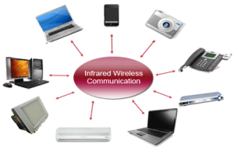

For a successful infrared communication, a photo LED transmitter and a photo diode receptor are required. The LED transmitter transmits the IR signal in the form of non-visible light that is captured and saved by the photoreceptor. So the information between the source and the target is transferred in this way. The source and destination can be mobile phones, TVs, security systems, laptops etc supports wireless communication.

Infrared wave lies in between visible light spectrum and microwaves. It has wavelength of 700-nm to 1-mm and frequency ranges from 300-GHz to 430-THz.

Infrared wave is used for very short range communication purposes such as television and it’s remote. Infrared travels in a straight line hence it is directional by nature. Because of high frequency range, Infrared cannot cross wall-like obstacles. It is used for short-range communication such as data transfer between two cell phones, TV remote operation, data transfer between a computer and cell phone resides in the same closed area.

### Characteristics of Infrared:

* It supports high bandwidth, and hence the data rate will be very high.
* Infrared waves cannot penetrate the walls. Therefore, the infrared communication in one room cannot be interrupted by the nearby rooms.
* An infrared communication provides better security with minimum interference.
* Infrared communication is unreliable outside the building because the sun rays will interfere with the infrared waves.

## Broadcast Radio

**Broadcast radio**is a wireless transmission medium that distributes radio signals through the air over long distances such as between cities, regions, and countries and short distances such as within an office or home. Bluetooth, UWB, Wi-Fi, and WiMAX communications technologies discussed earlier in this chapter use broadcast radio signals.

[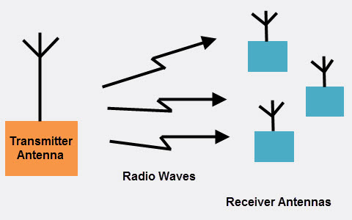](https://www.elprocus.com/wp-content/uploads/2014/12/Broadcast-Radio.jpg) Broadcast Radio

The first wireless communication technology is the open radio communication to seek out widespread use, and it still serves a purpose nowadays. Handy multichannel radios permit a user to speak over short distances, whereas citizen’s band and maritime radios offer communication services for sailors. Ham radio enthusiasts share data and function emergency communication aids throughout disasters with their powerful broadcasting gear, and can even communicate digital information over the radio frequency spectrum

Mostly an audio broadcasting service, radio broadcasts sound through the air as radio waves. Radio uses a transmitter which is used to transmit the data in the form of radio waves  to a receiving antenna([Different Types of Antennas](https://www.elprocus.com/different-types-of-antennas-with-properties-and-thier-working/)). To broadcast common programming, stations are associated  with  the radio N/W’s. The broadcast happens either in simulcast or syndication or both. Radio broadcasting may be done via cable FM, the net and satellites. A broadcast sends information over long distances at up to two megabits/Sec (AM/FM Radio).

## Cellular Radio

**Cellular radio**is a form of broadcast radio that is used widely for mobile communications, specifically wireless modems and cell phones. A cell phone is a telephone device that uses high-frequency radio waves to transmit voice and digital data messages.

Some mobile users connect their notebook computer or other mobile computer to a cell phone to access the Web, send and receive e-mail, enter a chat room, or connect to an office or school network while away from a standard telephone line.

**It** has other popular names as cellular mobile or mobile phone. Radio is basically a device, which uses receiver and transmitter. Wireless communication can also be carried out without using radio. The interference caused by high power line to radio transmission is also an example of wireless communication though it is termed as noise. Inductive and conductive circuits and devices can communicate wirelessly for limited distance with less reliability and implementation problem. Therefore, these techniques cannot be termed as radio transmission.

The term radio may be defined as consisting of modulation and radiation of the signal.. Therefore, a transmitter and an antenna are used to modulate and radiate the modulated signal within radio spectrum. On the hand at the receiving end, an antenna and a receiver is required to demodulate the signal. If the transmitting and receiving end are receiving and transmitting, a transceiver (consisting of transmitter and receiver operation) is employed. In telephone system as we know that a voice with bandwidth of approximately 4 kHz modulates the current of a telephone line. Wireless can be defined as the radio transmission and reception of signals by means of high frequency electrical waves without a connecting wire.

[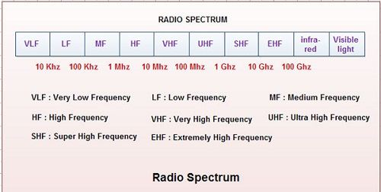](http://ecomputernotes.com/images/Radio-Spectrum.jpg)

A cellular system is the communication system that divides a geographic region into sections, called cells, each having its own dedicated frequency. The frequency of a cell may be reused after the interfere once zone. Now, we can define cellular radio or cellular mobile or mobile phone as a communication system that consists of a combination of radio transmission and Public Switched Telephone Network (PSTN) to permit telephone communication to and from mobile subscribers within a specified area. This requires a cellular architecture, which has been described in the subsequent sections. For digital communications, several competing cellular systems exist. These are Global System for Mobile Communication (GSM), CDMA etc.

## Microwaves

**Microwaves**are radio waves that provide a high-speed signal transmission. Microwave transmission, often called fixed wireless, involves sending signals from one microwave station to another Microwaves can transmit data at rates up to 4,500 times faster than a dial-up modem.

A microwave station is an earth-based reflective dish that contains the antenna, transceivers, and other equipment necessary for microwave communications. Microwaves use line-of-sight transmission. To avoid possible obstructions, such as buildings or mountains, microwave stations often sit on the tops of buildings, towers, or mountains.

[Microwave wireless communication](https://www.elprocus.com/introduction-to-types-of-microwave-antennas-in-communication-systems/) is an effective type of communication, mainly this transmission uses radio waves, and the wavelengths of radio waves are measured in centimeters. In this communication, the data or information can be transfers using two methods. One is satellite method and another one is terrestrial method.

[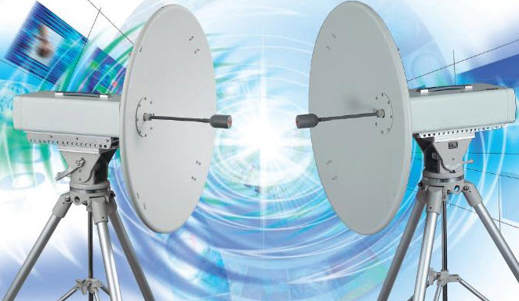](https://www.elprocus.com/wp-content/uploads/2014/12/microwave-communciation.jpg)Microwave Communication

Wherein satellite method, the data can be transmitted through a satellite that orbit 22,300 miles above the earth. Stations on the earth send and receive data signals from the satellite with a frequency ranging from 11GHz-14GHz and with a transmission speed of 1Mbps to 10Mbps. In terrestrial method, in which two microwave towers with a clear line of sight between them are used, ensuring no obstacles to disrupt the line of sight. So it is used often for the purpose of privacy. The frequency range of the terrestrial system is typically 4GHz-6GHz and with a transmission speed is usually 1Mbps to 10Mbps.

The main disadvantage of microwave signals is, they can be affected by bad weather, especially rain.

Microwave transmission is used in environments where installing physical transmission media is difficult or impossible and where line-of-sight transmission is available. For example, microwave transmission is used in wide-open areas such as deserts or lakes; between buildings in a close geo- graphic area; or to communicate with a satellite. Current users of microwave transmission include universities, hospitals, city governments, cable television providers, and telephone companies. Home and small business users who do not have other high-speed Internet connections available in their area also opt for lower-cost fixed wireless plans.

## Satellite Communications

A **satellite**communicationis a space station that receives microwave signals from an earth-based station, amplifies (strengthens) the signals, and broadcasts the signals back over a wide area to any number of earth-based stations.

These earth-based stations often are microwave stations. Other devices, such as smart phones and GPS receivers, also can function as earth-based stations. Transmission from an earth-based station to a satellite is an uplink. Transmission from a satellite to an earth-based station is a downlink. , it is widely spread all over the world to allow users to stay connected almost anywhere on the earth. When the signal (a beam of modulated microwave) is sent near the satellite then, satellite amplifies the signal and sent it back to the antenna  receiver which is located on the surface of the earth. Satellite communication contains two main components like the space segment and the ground segment. The ground segment consists of  fixed or mobile transmission, reception and ancillary equipment and the space segment, which mainly is the  satellite itself.

[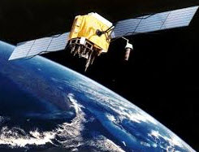](https://www.elprocus.com/wp-content/uploads/2014/12/satellite-communciaiton.jpg)Satellite Communications

Applications such as air navigation, television and radio broadcasts, weather forecasting, video conferencing, paging, global positioning systems, and Internet connections use communications satellites. With the proper satellite dish and a satellite modem card, consumers access the Internet using satellite technology. With satellite Internet connections, however, uplink transmissions usually are slower than downlink transmissions. This difference in speeds usually is acceptable to most Internet satellite users because they download much more data than they upload. Although a satellite Internet connection is more expensive than cable Internet or DSL connections, sometimes it is the only high-speed Internet option in remote areas.

# Sources

[**www.javatpoint.com**](http://www.javatpoint.com)

[**www.titorialspoint.com**](http://www.titorialspoint.com)

[**www.commotionwireless.net**](http://www.commotionwireless.net)

[www.networkworld.com](http://www.networkworld.com)